LAB # 01
INTRODUCTION TO THE PROLOG LANGUAGE

OBJECTIVE
Study the features of the Prolog Language and basic structure of Prolog program.

THEORY
Prolog is the result of many years of research work. Alain Colmerauer developed the first, official version of Prolog at the University of Marseilles, France in the early 1970s as a tool for PROgramming in LOGic. The result was a language far more powerful than even today's well-known programming languages, like Pascal and C. A Prolog program for a given application will typically require only one tenth as many program lines as the corresponding C++ program.
Today, Prolog is a very important tool in programming artificial intelligence applications and in the development of expert systems. The demand for more "user friendly" and intelligent programs is another reason for Prolog's growing popularity. But the most important benefits of Prolog apply equally well to any application domain: by allowing the programmer to model the logical relationships among objects and processes, complex problems are inherently easier to solve, and the resulting program is easier to maintain through its lifecycle. With Prolog, applications such as customized knowledge bases, expert systems, natural language interfaces, and smart information management systems are now within your programming domain.
Prolog is what is known as a declarative language. This means that given the necessary facts and rules, Prolog will use deductive reasoning to solve your programming problems. This is in contrast to traditional computer languages, such as C, BASIC and Pascal, which are procedural languages. In a procedural language, the programmer must provide step-by-step instructions that tell the computer exactly how to solve a given problem. In other words, the programmer must know how to solve the problem before the computer can do it. The Prolog programmer, on the other hand, only needs to supply a description of the problem and the ground rules for solving it. From there, the Prolog system is left to determine how to find a solution.
Because of this declarative (rather than procedural) approach, well-known sources of errors such as loops that carry out one too many or one too few operations are eliminated right from the start. Prolog encourages the programmer to start with a well-structured description of the problem, so that, with practice, Prolog can also be used as both a specification tool, and the implementation vehicle for the specified product.

Starting the Visual Prolog Environment
The installation program will install a program group with an Icon, which is normally used to start the Prolog environment. However, there are many ways to start an application in the GUI World, if you prefer another method, you can just start the VIP.EXE down in the BIN\WIN\16 or the BIN\WIN\32 directories under the main VIP directory.
If Prolog had an open project (a .VPR file) last time it was closed on your computer, it will automatically reopen this project next time it starts. For the examples in this manual, you do not need to have an open project.

Opening an Editor Window
To create a new edit window, you can use the menu command File | New. This will bring up a new editor window with the title "NONAME".
The editor is a fairly standard text editor. It is documented in the VDE manual, but you should be able to use cursor keys and the mouse as you are used to in other editors. It supports cut, copy and Paste and Undo / Redo, which can all be activated from the Edit menu. Also the Edit menu shows the accelerator keys associated for these actions.

Running and Testing a Program
To check, that your system is set up properly, you should try to type in the following text in the window:
GOAL write("Hello world"),nl.
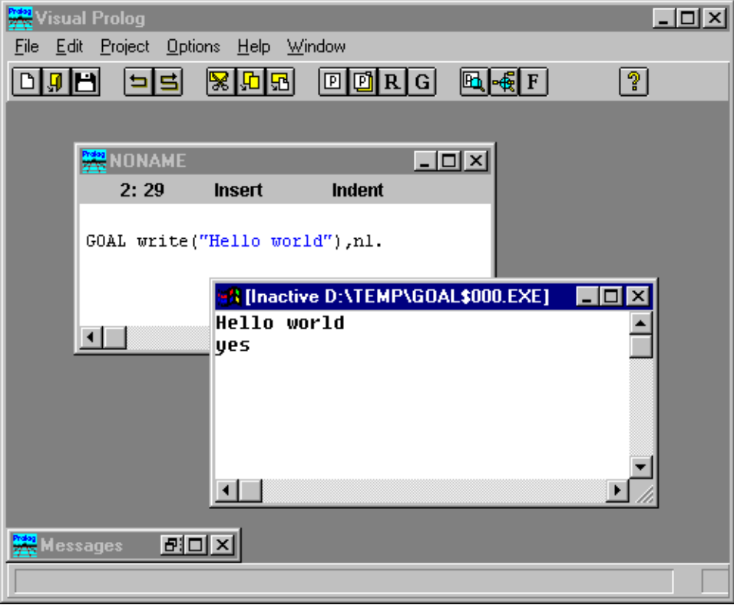
This is what is called a GOAL in the Prolog terminology, and this is enough to be a program that can be executed. To execute the GOAL, you should activate the menu item Project | Test Goal, or just press the accelerator key Ctrl+G. If your system is installed properly, your screen will look like the following:

The result of the execution will come up in a separate window, which you must close before you can test another GOAL.
(The Prolog system treats the GOAL as a program, which it compiles, links and generates a Windows executable from. It uses the EASYWIN strategy, which is described in the VDE manual.).

Handling Errors
If you, like all programmers do, happen to make some errors in your program, the Prolog system will display an error window, which contains a list of errors. You can double-click on one of these errors to come to the position of the error in the source text.

Language Background
In Prolog, you arrive at solutions by logically inferring one thing from something already known. Typically, a Prolog program isn't a sequence of actions - it's a collection of facts together with rules for drawing conclusions from those facts. Prolog is therefore what is known as a declarative language.
Prolog is based on Horn clauses, which are a subset of a formal system called predicate logic. Don't let this name scare you. Predicate logic is simply a way of making it clear how reasoning is done. It's simpler than arithmetic once you get used to it. Prolog uses a simplified variation of predicate logic syntax because it provides an easy-to-understand syntax very similar to natural language, and because computers are not as fast, large, or as inexpensive as we would like. If Prolog were to accept English statements, the compiler would need to know every possible way something could be worded in English. In many cases, it would take many times longer to translate the program into something the computer understands than it would to run the program. The computer hardware needed to run such a system would be monstrous.
Prolog includes an inference engine, which is a process for reasoning logically about information. The inference engine includes a pattern matcher, which retrieves stored (known) information by matching answers to questions. Prolog tries to infer that a hypothesis is true (in other words, answer a question) by questioning the set of information already known to be true. Prolog's known world is the finite set of facts (and rules) that are given in the program.
One important feature of Prolog is that, in addition to logically finding answers to the questions you pose, it can deal with alternatives and find all possible solutions rather than only one. Instead of just proceeding from the beginning of the program to the end, Prolog can actually back up and look for more than one way of solving each part of the problem.
Predicate logic was developed to easily convey logic-based ideas into a written form. Prolog takes advantage of this syntax to develop a programming language based on logic. In predicate logic, you first eliminate all unnecessary words from your sentences. You then transform the sentence, placing the relationship first and grouping the objects after the relationship. The objects then become arguments on which the relationship acts upon. For example, the following sentences are transformed into predicate logic syntax:

Natural Language: | Predicate Logic:
A car is fun.  A rose is red. | fun(car).  Red(rose).
Bill likes a car if the car is fun. | Likes(bill, Car) if fun(Car).

A Prolog program is made up of two types of phrases (also known as clauses): facts and rules. Facts are relations or properties that you, the programmer, know to be true. Rules are dependent relations; they allow Prolog to infer one piece of information from another. A rule becomes true if a given set of conditions is proven to be true. Each rule depends upon proving its conditions to be true.
In Prolog, all rules have two parts: a head and a body separated by the special :- token. The head is the fact that would be true if some number of conditions were true. This is also known as the conclusion or the dependent relation. The body is the set of conditions that must be true so that Prolog can prove that the head of the rule is true. As you may have already guessed, facts and rules are really the same, except that a fact has no explicit body. The fact simply behaves as if it had a body that was always true.
Once you give Prolog a set of facts and/or rules, you can proceed to ask questions concerning these; this is known as querying the Prolog system. Prolog always looks for a solution by starting at the top of the facts and/or rules, and keeps looking until it reaches the bottom.
Prolog's inference engine takes the conditions of a rule (the body of the rule) and looks through its list of known facts and rules, trying to satisfy the conditions. Once all the conditions have been met, the dependent relation (the head of the rule) is found to be true. If all the conditions can't be matched with known facts, the rule doesn't conclude anything.
A typical program has the following basic structure:
DOMAINS
/* ...
domain declarations
... */
PREDICATES
/* ...
predicate declarations
... */
CLAUSES
/* ...
clauses (rules and facts)
... */
GOAL
/* ...
subgoal_1,
subgoal_2,
etc. */
- The CLAUSES section is where you put the facts and rules that Prolog will operate on when trying to satisfy the program's goal. These facts and rules are separated by commas (which represent AND – denoted by ‘,’) or semi-colons (which represent OR – denoted by ‘;’). A fact clause is always terminated by a full stop. A rule is declared by ‘:-‘ (which represents an IF condition).
- The PREDICATES section is where you declare your predicates and the domains (types) of the arguments to your predicates. Predicate names must begin with a letter (preferably lower-case), followed by a sequence of letters, digits, and underscores, up to 250 characters long. You can't use spaces, the minus sign, asterisks, or slashes in predicate names. Predicate declarations are of the form
PREDICATES
predicateName(argument_type1, argument_type2, ..., argument_typeN)
argument_type1, ..., argument_typeN
These are either standard domains or domains that you've declared in the DOMAINS section. Declaring the domain of an argument and defining the argument's type is the same thing.
- The DOMAINS section is where you declare any nonstandard domains you're using for the arguments to your predicates. Domains in Prolog are like types in other languages. Prolog's standard domains are char, byte, short, ushort, word, integer, unsigned, long, ulong, dword, real, string, and symbol; the more specialized standard domains are covered in other chapters. The basic domain declarations are of the form:
DOMAINS
argument_type1, ..., argument_typeN = <standard domain>
argument_1, ..., argument_N)= <compound domain 1>;
<compound domain 2>;
< ... >;
<compound domain N>;

- Standard prolog domains are:
Name | Comments
Integer | Any integer number in range of –32768 to +32767
Real | Any number which may have a fractional part and /or exponent with it. Allowed range is (+/-) 1E-307 to (+/-) 1E+308
Char | Any single letter/digit enclosed within single quotes (inverted commas)
String | Any sequence of characters – letters, digits, signs and spaces – enclosed within double quotation marks. The maximum number of characters allowed is 250.
Symbol | A string with its first character in lowercase. Double quotes may or may not be used. They are like strings, but are processed more efficiently than strings.
Files | Symbolic file names
Lists | Used by lists. A list is a sequence of any of the above domain’s elements, enclosed within square brackets. It is declared in domains section. The declared list is represented by an asterisk (*) added at the end of the domain name applying to each element of the list.

- The GOAL section is where you put your program's internal goal; this allows the program to run independent of the development environment. With an internal goal, Prolog only searches for the first solution, and the values to which variables are bound are not displayed.
- If you don't use an internal goal, you'll enter an external goal in the Dialog window at run time. With an external goal, Prolog searches for all solutions, and displays the values to which variables are bound.
- Comments make your programs easier to read; you can enclose a comment with delimiters /* like this */ or precede a single-line comment with a percent sign, % like this.
- The arity of a predicate is the number of arguments that it takes; two predicates can have the same name but different arity. You must group a predicate's different arity versions together in both the PREDICATES and CLAUSES sections, but different arities are treated as completely different predicates.
Prolog facts and rules receive information by being called with arguments that are constants or bound variables; they return information to the calling procedure by binding variable arguments that were unbound.

EXAMPLE PROGRAMS

Program 1

PREDICATES nondeterm likes(symbol,symbol)
CLAUSES likes(mary,food).
likes(mary,juice).
likes(john,juice).
likes(john,fruit).
GOAL
likes(mary,food).

EXERCISES
- Type the above examples in Visual Prolog environment and execute them individually.
- Using Program#1 Execute following Goals:
- likes(john,juice)
- likes(john,food).

